

***EVALUATION OF INTERNSHIP REPORT***

***B.Tech: III Year***

***Department of Computer Science &amp; Information Technology***

***Name of the Student:- Ishwar Rajput***

***Branch & section:- CSIT 2***

***Roll No:- 0827CI201081***

***Year:- 2022***

***Department of Computer Science &amp; Information Technology***

***AITR, Indore***

**ACROPOLIS INSTITUTE OF TECHNOLOGY & RESEARCH, INDORE**

**Department of Computer Science & Information Technology**

***Certificate***

***Certified that training work entitled “Alexa” is a bonafied work carried out after forth semester by “Ishwar Rajput “ in partial fulfilment for the award of the degree of Bachelor of Technology in Computer Science and Information Technology from “Prof. Garima Kumrawat” Acropolis Institute of Technology and Research during the academic year 2022-23.***

**Name and Sign of Training Coordinator Name & Sign of Internship Coordinator**

**Prof. Garima Kumrawat.**

***ACROPOLIS INSTITUTE OF TECHNOLOGY & RESEARCH, INDORE***

***Department of Computer Science & Information Technology***

***ACKNOWLEDGEMENT***

*I would like to acknowledge the contributions of the following people without whose help and guidance this report would not have been completed. I acknowledge the counsel and support of our training coordinator prof Garima Kumrawat , CSIT Department, with respect and gratitude, whose expertise, guidance, support, encouragement, and enthusiasm has made this report possible. Their feedback vastly improved the quality of this report and provided an enthralling experience. I am indeed proud and fortunate to be supported by him/her. I am also thankful to Dr. Shilpa Bhalerao, H.O.D of Computer Science Information Technology Department, for her constant encouragement, valuable suggestions and moral support and blessings. Although it is not possible to name individually, I shall ever remain indebted to the faculty members of CSIT Department, for their persistent support and cooperation extended during this work.*

*Student Name: Ishwar Rajput*

*Student Enrollment No.: 0827CI201081*

***ACROPOLIS INSTITUTE OF TECHNOLOGY &amp; RESEARCH, INDORE***

***INDEX***

S.no CONTENTS Page no

1. Introduction to Alexa

2. Objectives

3. Project undertaken

4. Screenshots of Project

5. Github Links

6. References/ Bibilography

* ***What is Alexa?***

*Alexa is Amazon’s cloud-based voice service available on more than 100 million devices from Amazon and third-party device manufacturers. With Alexa, you can build natural voice experiences that offer customers a more intuitive way to interact with the technology they use every day. We offer a collection of tools, APIs, reference solutions, and documentation to make it easier to build for Alexa.  It can be used as smart phone and Echo product*.

* ***Which technology is used in Alexa?***

***Automatic speech recognition (ASR)****is technology that converts spoken words into text. In short, it's the first step in enabling voice technologies like Amazon Alexa to respond when we ask, “Alexa, what's it like outside?” With ASR, voice technology can detect spoken sounds and recognize them as words.*

* ***How Many programming language in Alexa?***

**Js, Java, Python, C#, Go, Ruby, or PowerShell**.

* ***Example of Alexa?***

*With conversational AI, voice-enabled devices like Amazon Echo are enabling the sort of magical interactions we've dreamed of for decades. Through a voice user interface (VUI), voice services like Alexa can communicate with people in ways that feel effortless, solve problems, and get smarter over time.*

* ***How to connect object with Alexa?***
* *Firstly we need to Raspberry Chip than we put a chip in object which we want to connect than we setup a setting in Voiceflow Than We can Use easily*
* *Voiceflow it is the Part of Alexa .we want to connect object so we need to Firstly Voiceflow. We have to create an account on Voiceflow tutorial than Voiceflow tutorial has many option like a Voicechatbot, VoiceAssistance etc.*
* *It is totally depend on us.*
* *How to connect with object is voicechatbot and assistance.*

*VoiceFlow*

* *How to create an Account*
* *How to Start*
* *How to add Skill*
* *How to connect text to Text*
* *How to connect Button in Text*
* *How to Setup*
* *How to Run*
* *Project*
* *How To share*
* ***How To create an Account on Voice flow***

*Firstly we go to the Google chrome and search Voiceflow tutorial Than Select First Link.*

***There are Show 2-3 Option to Login***

*1. Continue with Google.*

*2. Continue with email.*

*3. Don’t have account.*

*We will do continue with Google.*

*Than it is ask what is you birthdate*

*We will fill up Our Birthday Date*

*Now we will reach on Voiceflow*

*Than Go to setting and edit our name.*

* ***What is the objective of Alexa ?***

*It is capable of voice interaction, music playback, making to-do lists, setting alarms, streaming podcasts, playing audiobooks, and providing weather, traffic, sports, and other real-time information, such as news. Alexa can also control several smart devices using itself as a home automation system.*

* ***How to start***

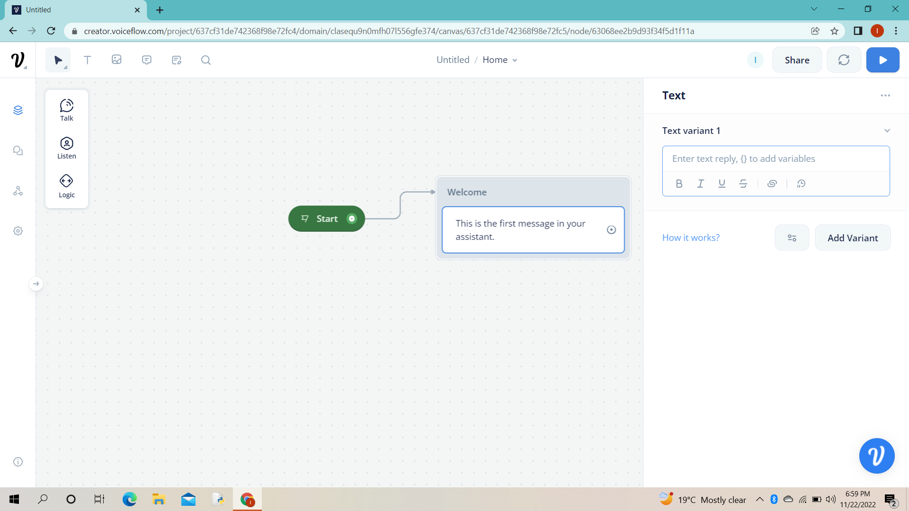

*In this picture we the see the start button and we can see that option*

*Is talk, listen and logic.*

*In “Talk” we select text, now we add our skills.*

* ***How to connect text to text***

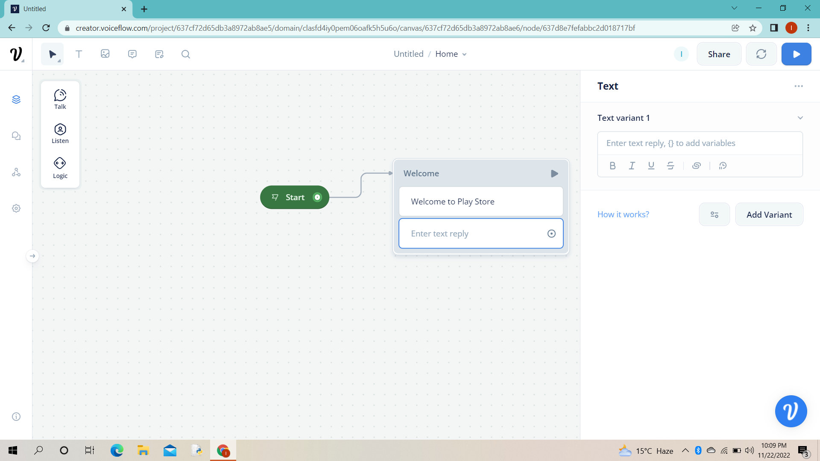

*In this image we can clearly see that start connect with text*

* ***How to connect button in text***

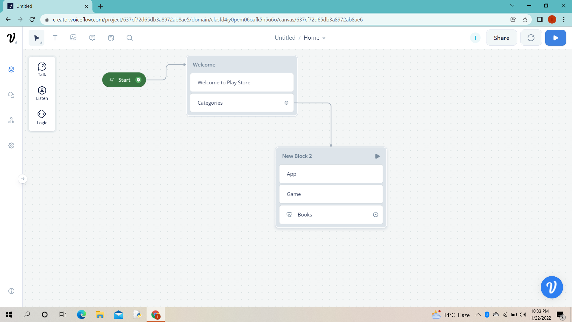

*In this we go to the listen button and select “Button” from it and make the different options like Books, Game and App.*

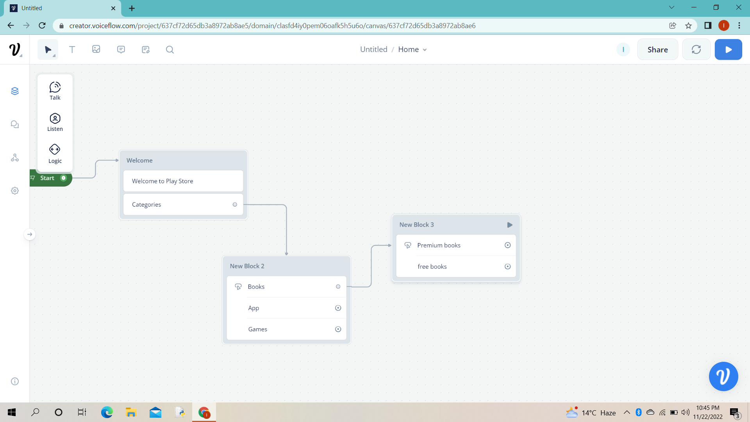

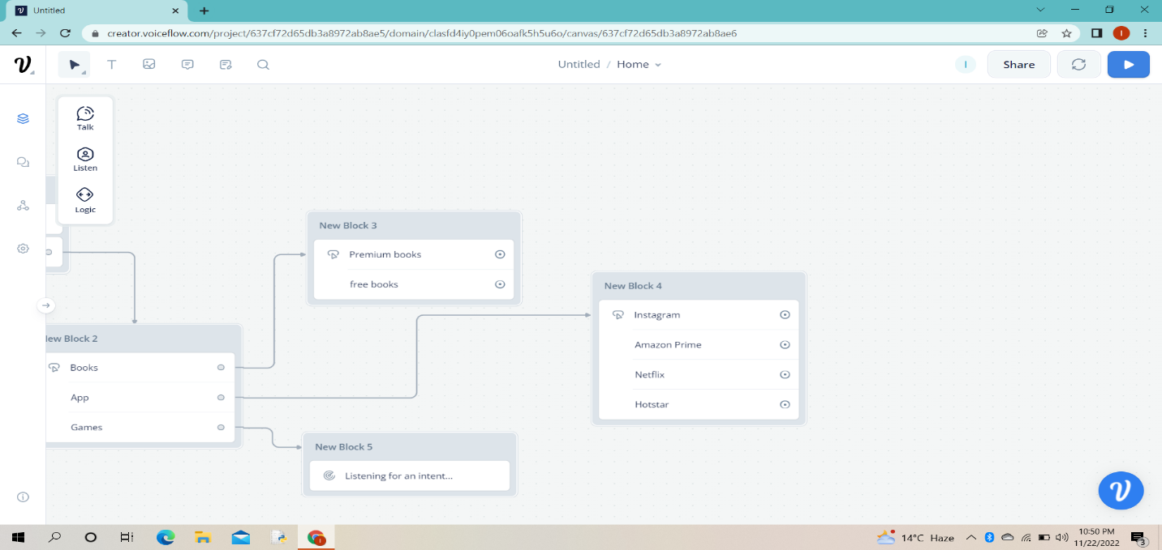

* ***When it is competed***

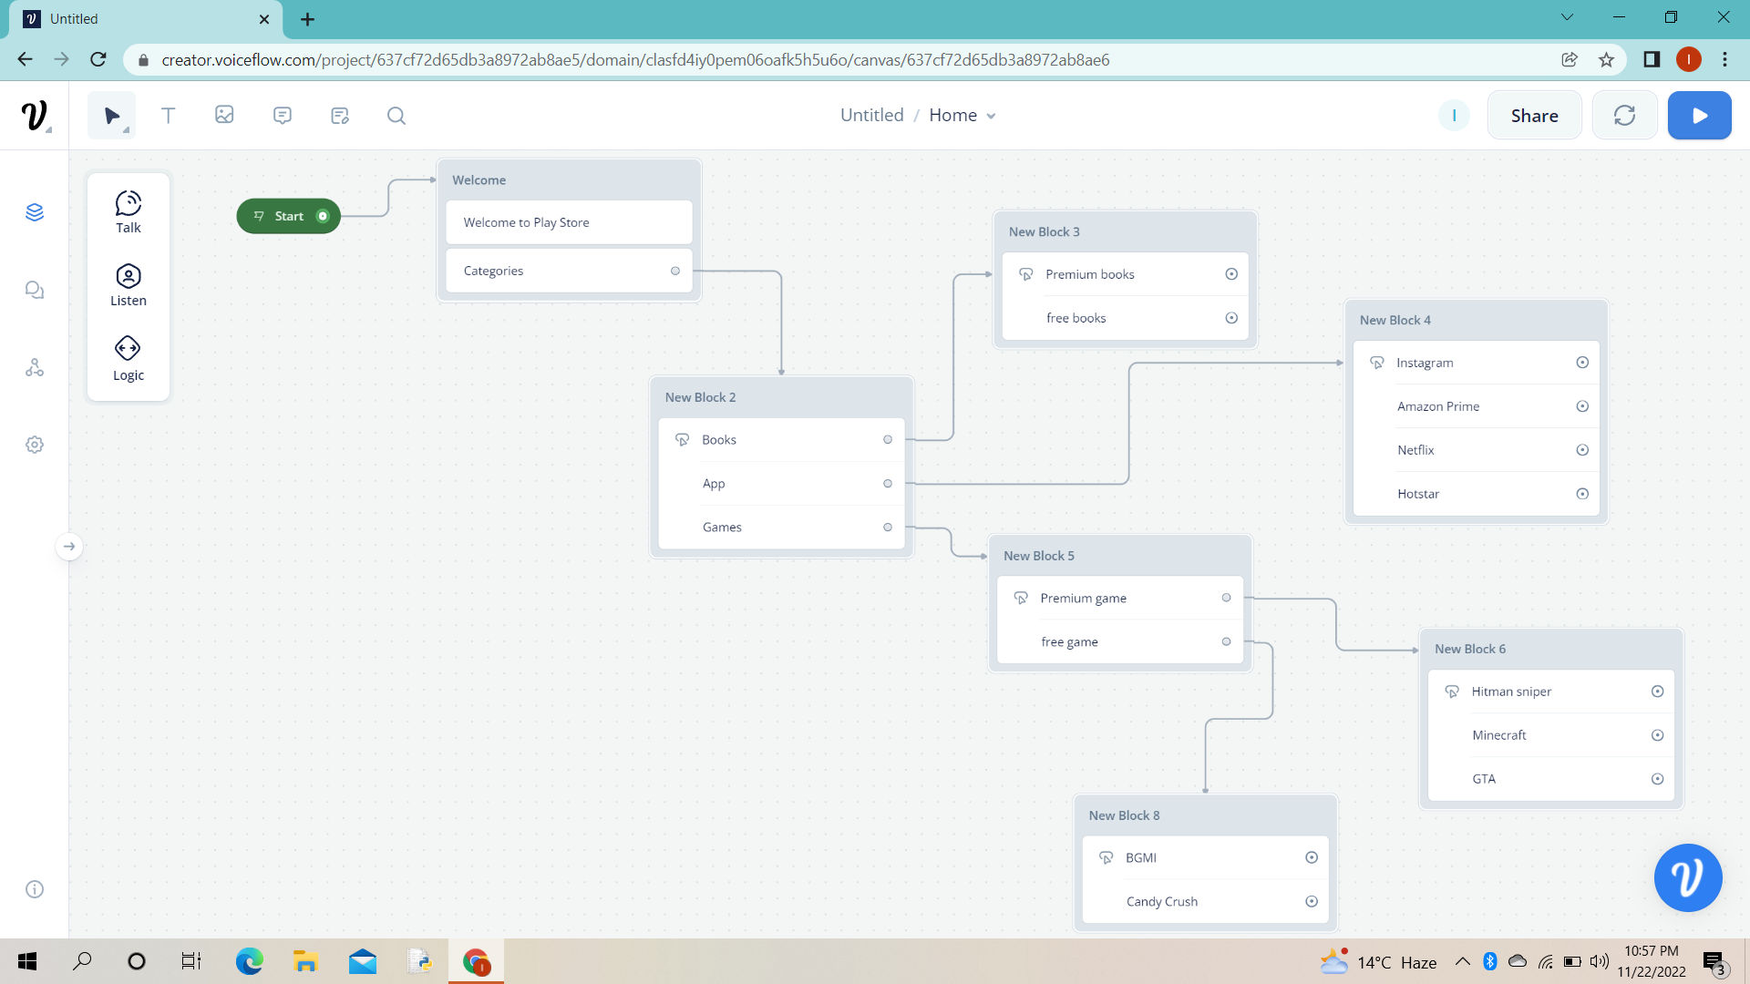

* ***Run test*** 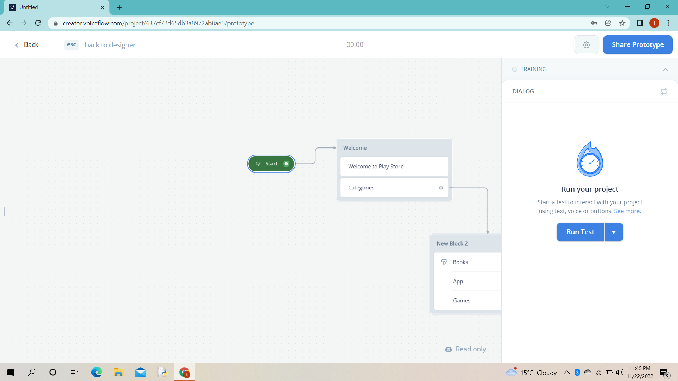

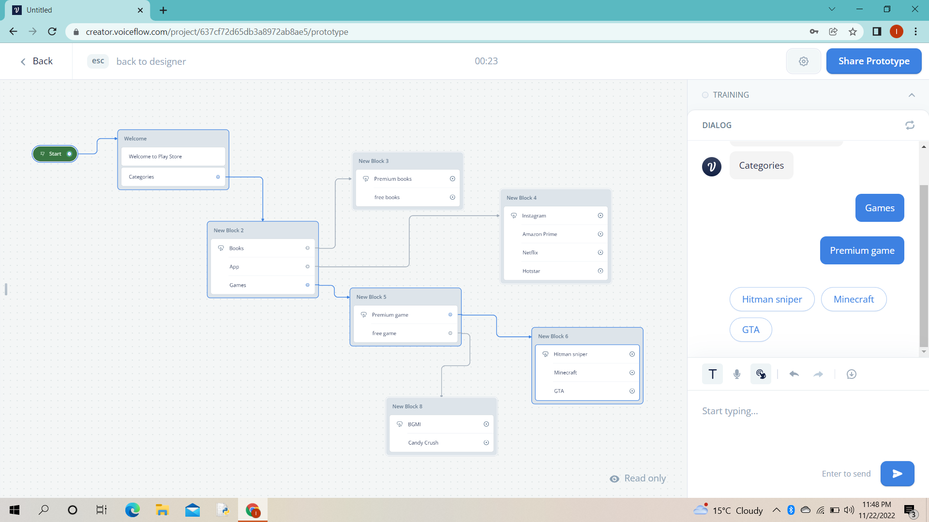

* ***Project link***
* [*https://creator.voiceflow.com/prototype/637cf72d65db3a8972ab8ae5*](https://creator.voiceflow.com/prototype/637cf72d65db3a8972ab8ae5)

***THANK YOU!***